

**ARIGNAR ANNA GOVERNMENT ARTS COLLEGE VILLUPURAM**

**DEPARTMENT OF STATISTICS**

**NAAN MUDHALVAN PROJECT**

**3RD YEAR B.SC STATISTICS**

**SHIFT-1**

**JOB APPLICATION TRACKIN SYSTEM**

**TEAM LEADER : Pavithra**

**TEAM MEMBER:**

1. **Muththamizh**
2. **Nareshkumar**
3. **Nagalingam**

**TEAM LEADER – Pavithra**

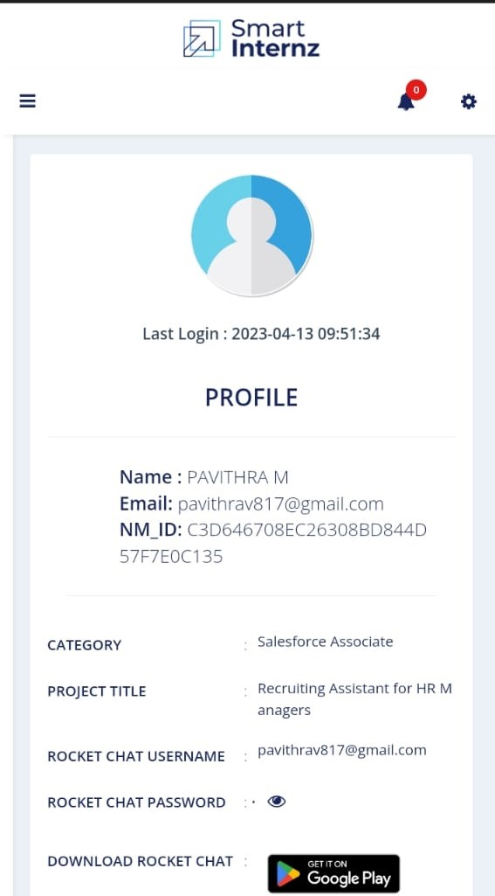

**TEAM MEMBER-1 (MUTHTHAMIZH)**

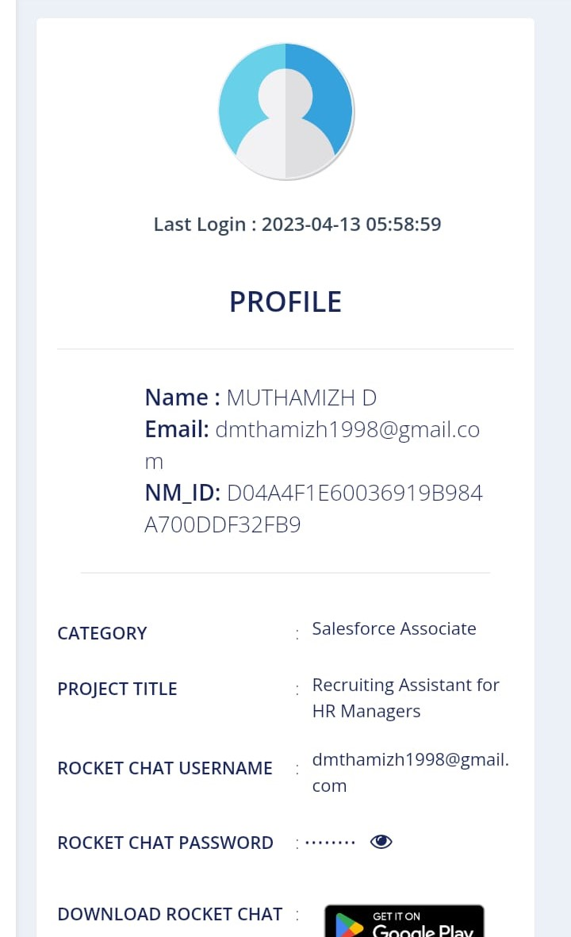

**TEAM MEMBER-2 (NARESHKUMAR)**

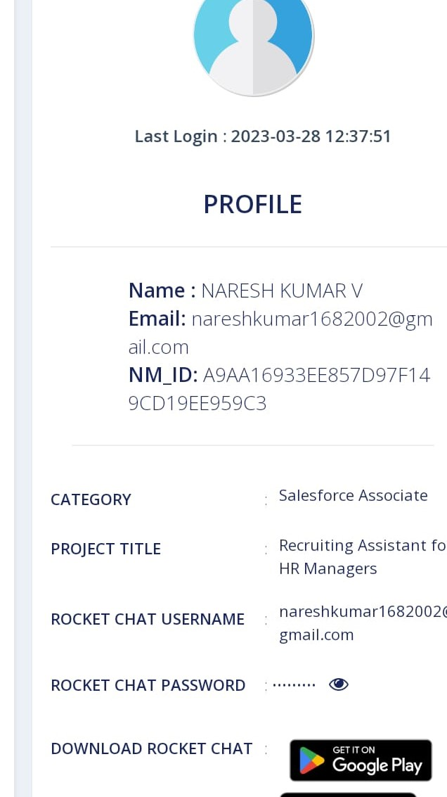

**TEAM MEMBER -3 (NAGALINGAM)**

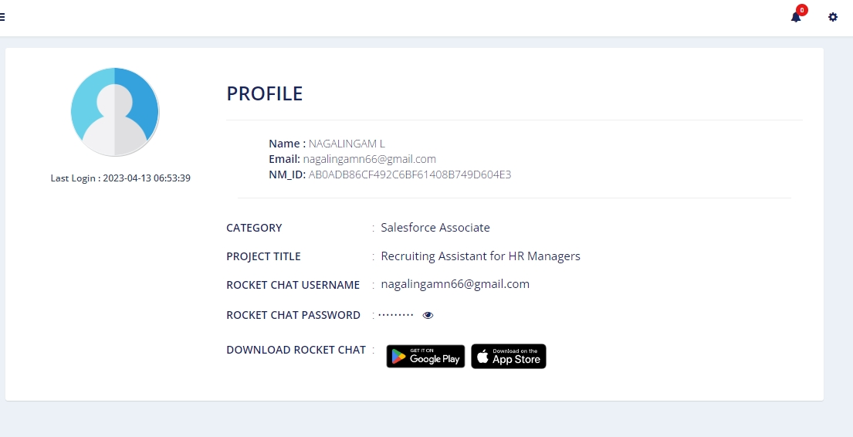

**1. INTRODUCTION**

**1.1 Overview**

Naan Mudhalvan platform aims to provide dynamic

information for college students on courses and relevant information

about industry specific skill offerings.

This will enable the students of TamilNadu to get training in their

chosen field of interest that will help them in achieving their career

goals.

The objective of this scheme is to identify potential training providers,

to impart various skill trainings based on current industry gaps.

Through this flagship program the students will be able to get trained

and ensure they get jobs according to their skill sets. We will also offer

career and academic guidance to students in state educational

institutions.

Naan Mudhalvan showcases 2000+ institutes and consequent 300+

career pathways**.**

**1.2 Purpose**

This Project use for more skills for Students in our Life.

* Salesforce

* Trailblazer

This program offers training in coding and robotics, as well as

guidance in nutrition, physical fitness, and overall development from

psychological counselors and therapists. Both in-person and virtual

training options will be available. A Guidance Bureau will be

established in every school to implement this program**.**

**2. Problem Definition & Design Thinking**

**2.1 Empathy Map**

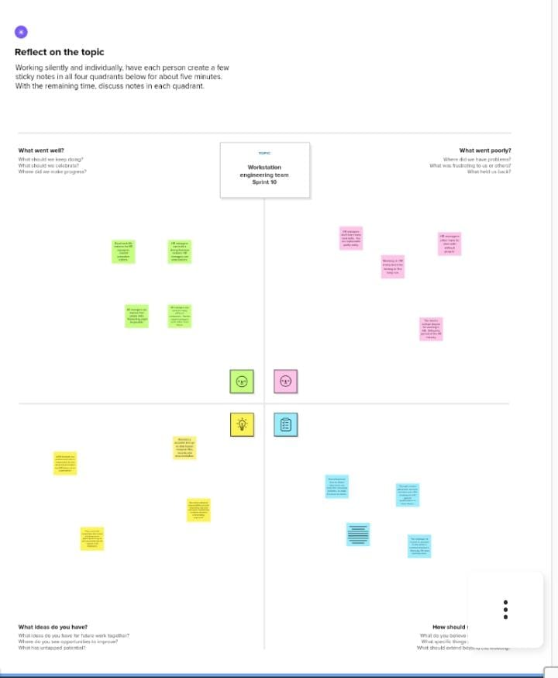

**2.2 Ideation & Brainstorming Map**

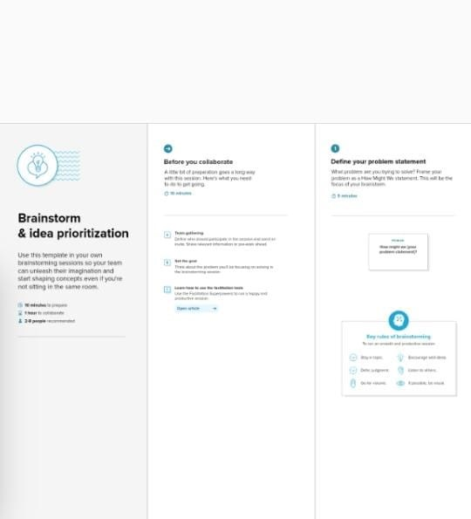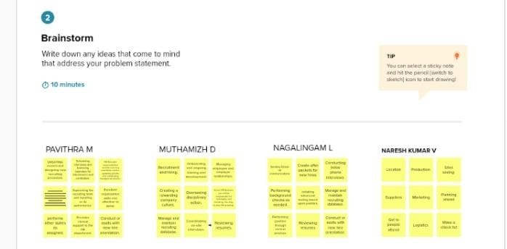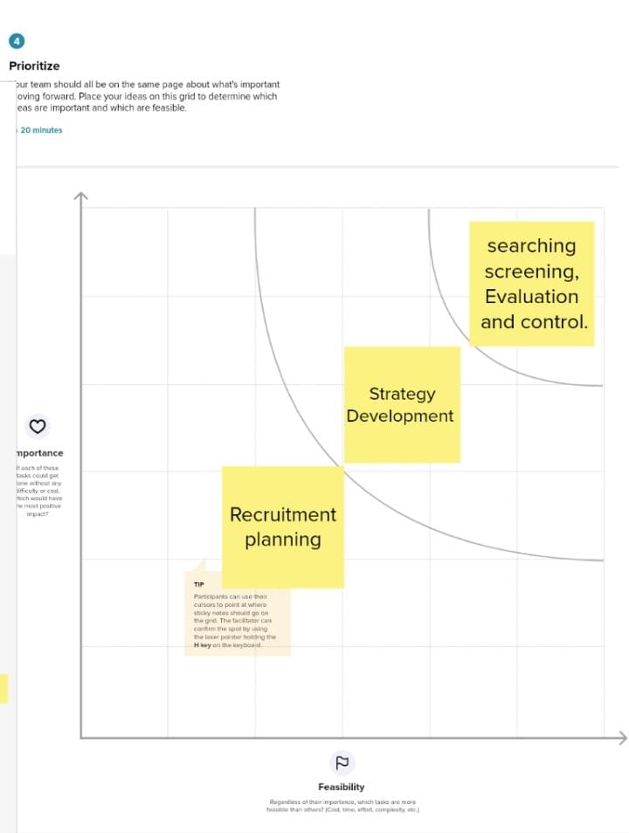

3. RESULT

3.1 Data modal:

**1.Creation Of Developer Account**

A Developer org has all the features and licenses you need to get started with Salesforce.

1. Search <https://developer.salesforce.com/>

2.Enter the following details like First name, last name, Email, Role, Company, Country/Region, Postal code, and Username must be unique.

3. Click sign me up, After a few min you will reserve a mail salesforce org and by using the verify account link you can create your new password.

4. Click save.

5. Search <https://login.salesforce.com/>

6. By using username and password you can into the salesforce org.  
The setup page will appear as below.  
Create a developer org and login with your login credentials.

**2. Package Installation For Recruiting App**

Click to launch the App Launcher, then click Playground Starter and follow the steps

1. Click the install a package tab.

2. Paste 04t0P000000N9rs into the field.

3. Click install.

4. Select install for admins only,

**3. Create A Custom Object For Job Posting Sites**

To create a custom object, follow these steps :

1. From setup click on object manager.  
  
2. Click create, select custom object.

3. Fill in the label as "Job Posting Site".

4. Fill in the plural label as "Job Posting Sites".

5. Record name : "Site Name"

6. Select the data type as "Text".

7. In the Optional Features section, select Allow Reports and Track Field History.  
  
8. In the Deployment Status section, ensure Deployed is

selected.

9. In the Search Status section, select Allow Search.

10. In the Object Creation Options section, select select these options:

Add Notes and Attachments related list to default page layout

Launch New Custom Tab Wizard after saving this custom obje

**Create A Custom Object For Reviews**

To create a custom object, follow these steps :

1. From setup click on object manager.

2. Click create, select custom object.

3. Fill in the label as "Review".

4. Fill in the plural label as "Reviews".

5. Record name : "Review Number"

6. Select the data type as "Auto Number".

7. Under display format enter "REV-{0000}".

8. Enter the starting number as 1.

9. In the Optional Features section, select Allow Reports and Track Field History.

10. In the Deployment Status section, ensure Deployed is selected.

11. In the Search Status section, select Allow Search.

12. In the Object Creation Options section, select Add Notes and Attachments related list to default page layout.

13. Leave everything else as is, and click Save.

**4. Create A Tab**

As we selected to launch a custom tab wizard in step 10, a custom tab wizard appears wherein we customize the look of the Job posting site object's tab. To do that :

1. To Select the Tab Style: Click the magnifying glass and select Real Estate

2. Click Next.

3. Leave the profile as is and click Next.

4. In the Add to Custom Apps section

5. Deselect Include Tab.

6. Select Append tab to users’ existing personal customizations.

7. Click Save.

**5. Create New Field For Job Posting Site**

From the object manager, click on the job posting site, then click on Fields & Relationships.

1. Click on new.  
  
2. Select the data type as URL.

3. Click Next.

4. For Field Label, enter the Job Posting Site URL.

5. Click Next, Next, and click Save & New.

Create a Fields for Job Posting site

1. Status

2. Technical site

3. Description

**Note:** Follow the steps Create the left over fields

1. Status

2. Technical site

3. Description

**6. Creating A Custom Junction Object**

1. From setup, click object Manager.

2. Click create, select custom object.

3. Enter the label as "Job posting".

4. Enter the plural label as "Job postings".

5. Enter the record name as "Job posting number".

6. select the data type as "Auto Number".

7. Enter the display format as "JOBPOST-{0000}"

8. Enter the Starting number as 1.  
  
9. Leave everything else as is, and click save.

**Create A Relationships Object**

Creating a master-detail relationship between Job posting and job posting site.

1. From setup, click object manager.

2. Select Job posting object, click on field and relationships, click new.

3. Select the data type as Master-detail relationship.

4. Click Next, relate to the Job posting site.

5. Enter the label Job Posting site.

6. Click next, next, next and save.

Creating a master-detail relationship between job posting and position.

1. From setup, click object manager.

2. Select Job posting object, click on field and relationships, click new.

3. Select the data type as Master-detail relationship.

4. Click Next, relate to position.

5. Enter the label Position.

6. Click next, next, next and save.

**7. Modifying The Page Layouts**

Modifying the page layouts :

1. From setup, click on object manager.

2. Click position, then page layouts.

3. Click down array next to the position layout and select edit.

4. Scroll down to the job posting related list, and click the wrench icon in the header to edit it.

5. From the available fields section, select

Job posting site : Status

Job posting site : Technical Site

6. Click add.

7. From the selected fields section, select job posting : Job posting number and click remove.  
  
8. Click ok, then save.

**Create A Page Layout For Review Object**

Create a Page layout for Review Object

**8. Creating A Validation Rule**

To create a validation rule:

Go to object manager, select the object on which validation rule has to be implemented, scroll down and click validation rule, New.

**Give details as:**

1. Rule name: Phone number validation rule.

2. Active: checked

3. Description: phone number should not be more than or less than 10 digits.

4. Under Error Condition Formula: write the condition using insert field, insert operator, insert function

5. Using check syntax: check if the formula you entered is valid or not.

6. Error Message: Please give a valid phone number

7. Error location: select field  
8. Save

**Create A Validation Rule For Technical Site Checkbox Is Equal To True.**

Create a Validation rule For Technical Site Checkbox is equal to True.

**9. Creation On Profile**

From Setup enter Profiles in the Quick Find box, and select Profiles.

1. From the list of profiles, find Standard User.

2. Click Clone.

3. For Profile Name, enter Event user profile.

4. Click Save  
  
5. While still on the Event profile page, then click Edit.

6. Scroll down to Custom Object Permissions and Give view all access permissions to the Order details, supplier, product, customer, category, payment.

**Create A Profile With The Profile Name As “Sales Profile”.**

Create a profile with the profile name as “Sales profile”.

**10. Creating A User**

From setup type “users” in quick find and select users, then click New User

a. First Name: Sanjay

b. Last Name: Gupta

c. Alias: Sanj

d. Email: provide your personal email id for future reference

e. Username: sanjaygupta@thesmartbridge.com

f. Nickname: Sanju

g. Role: leave it as default

h. User License: Salesforce

i. Profile: Event User Profile

**Create A User With A Username As “Abhilash Garapati”, And Assign Him The Sales Profile.**

Create a user with a username as “Abhilash Garapati”, and assign him the sales profile.

**11. Creating A Permission Set**

1. From setup search “permission sets” in quick find and select permission set then click on New.  
  
2. Enter label as: Supplier Permits and Save.  
  
3. After saving the permission click on the Manage assignment  
  
4. Now click on the Add Assignment  
  
5. Now select the users and click on save

**Create A Permission Set For Review Object**

Create a Permission set for Review object

**12. Reports**

1. From the Reports tab, click New Report.  
  
2. Select the report type Attendees with events for the report, and click Create.  
  
3. Customize your report accordingly and include all fields, then save or run it.

**Create A Report For Review And Job Posting Objects.**

Create a report for review and Job Posting Objects.

**3.2 Activity & screenshot**

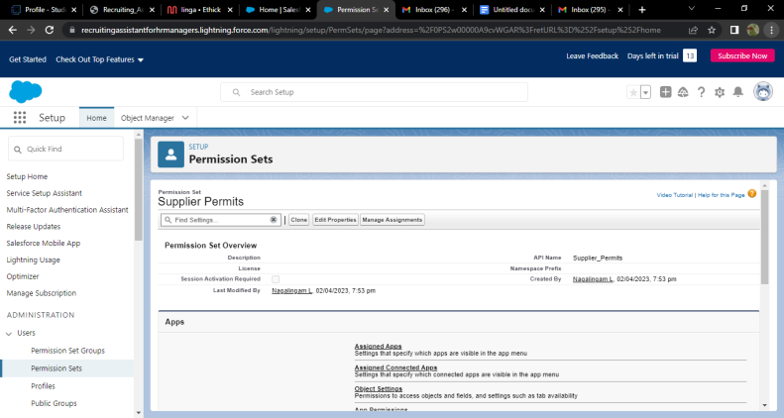 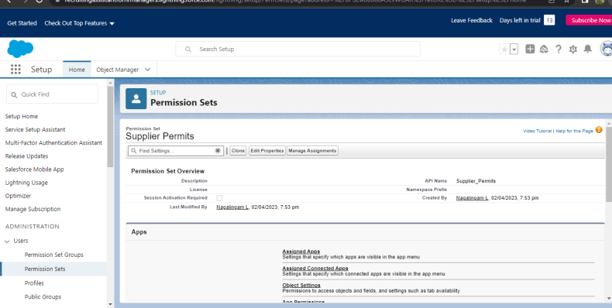 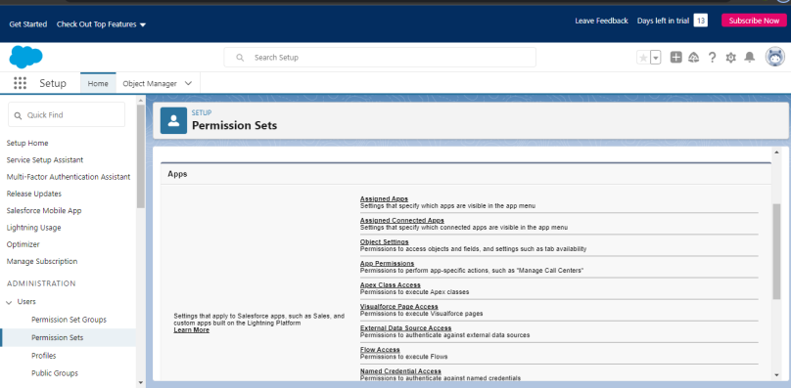 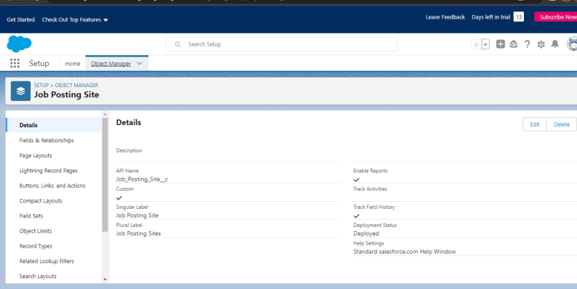 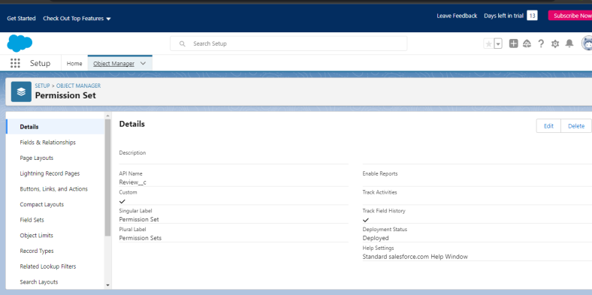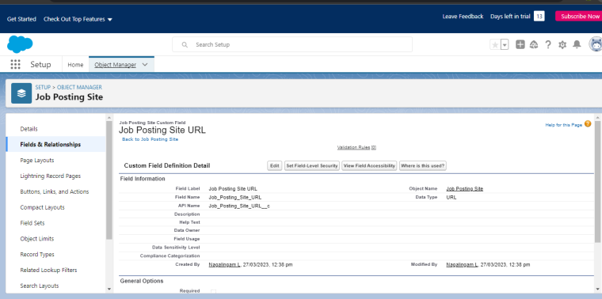 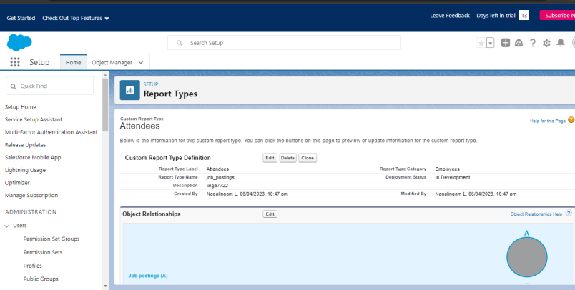

**4. Trailhead profile public URL**

Team ID: AB0ADB86CF492C6BF61408B749D604E3

Team Size : 4

**Team Leader**

Pavithra : https://trailblazer.me/id/kghvsuycejxsoipiwjnu8yhhjiisbhu97ggbhbih98us

Team member :

1. **MUTHTHAMIZH:** https://trailblazer.me/id/zxcvbnsdfgh34567wertyusdfghxcvbndfg
2. Nareshkumar : https://trailblazer.me/id/nkumar2888
3. Nagalingam : https://trailblazer.me/id/nagal50

**5.ADVANTAGES & DISADVANTAGES**

**ADVANTAGES** :

Advantage #1: Faster hiring. Using a recruitment agency will shorten the time needed to fill your open job positions. ...

Advantage #2: Higher quality candidates. ...

Advantage #3: Specialist knowledge.

**DISADVANTAGES:**

Disadvantage #1: Higher cost. ...

Disadvantage #2: No cultural fit. ...

Disadvantage #3: Lack of employer branding.

**6. APPLICATIONS**

Dear Sir/Madam, I would like to apply for the position of HR Officer at (Institute name). I have a Certificate in Higher Education (educational qualification) in Business and Professional Administration 9Subject name) from (university name). I have studied human resources management as part of my course

**Job Application:**

Write a clear subject line. ...

Include a salutation. ...

Introduce yourself in the first sentence. ...

Turn your cover letter into the body of your email. ...

Close with details. ...

Sign your email. ...

Attach your materials. ...

Proofread before you hit “send”

**7. CONCLUSION :** On the one hand, the Soft and Hard Human ResourceManagement influence on the business and lets them development rapidly. Itcan improve employee's motivation in a business and pay attention tocompany's policy and law respectively, which can increase the efficiency ofcompany and get higher profits.

**8. FUTURE SCOP:** One should remember that HR needs to adapt and be agile i.e. an HR professional must not stop learning. HR will not be replaced, but HR professional must take up relevant courses to empower your working and be in a race. Thus, MBA in HR future scope is bright

**Salary of HR in future** : Future Group HR Executive salary in India ranges between ₹ 2.4 Lakhs to ₹ 4.0 Lakhs with an average annual salary of ₹ 3.2 Lakhs

**HR SCOP**: A human resources (HR) assistant is a certified professional who handles the daily administrative and HR duties of an organization. They assist HR managers with recruitment, record maintenance, and payroll processing, and provide clerical support to all employees.